REST API Fundamentals

University Student Records API

Backend Development Project 1

Submitted By:
Nosheen Afzal

Batch 2026 | DecodeLabs Industrial Training

Table of Contents
Introduction 2
Project Objectives 2
Technologies Used 3
Project Structure 3
Architecture Diagram 3
API Endpoints 3
Testing and Results 4
GitHub Repository 4
Conclusion 4

Introduction
This project was developed as part of Backend Development Project 1: REST API Fundamentals. The objective was to build a stateless web server capable of handling HTTP requests and returning structured JSON responses. The project demonstrates the implementation of RESTful API routes using Node.js and Express.js.

Project Objectives
- Create a local web server using Node.js and Express.js.
- Implement GET routes for retrieving data.
- Implement a POST route for adding new data.
- Return structured JSON responses.
- Test API endpoints using browser and Postman.
- Upload the completed project to GitHub.

Technologies Used
Technology | Purpose
Node.js | Runtime Environment
Express.js | Backend Framework
Postman | API Testing
Git | Version Control
GitHub | Repository Hosting

Project Structure
student-records-api
│
├── Documentation
├── Screenshots
├── node_modules
├── app.js
├── package.json
├── package-lock.json
├── README.md
└── .gitignore

API Endpoints
Method | Endpoint | Description
GET | / | Welcome Message
GET | /students | Get All Students
GET | /students/:id | Get Student By ID
POST | /students | Add New Student

Architecture Diagram
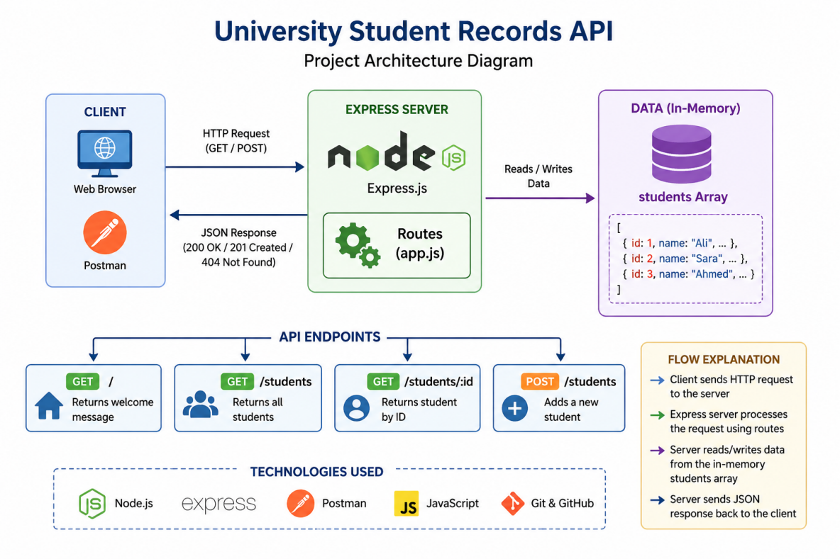

Testing and Results
Home Route (/)
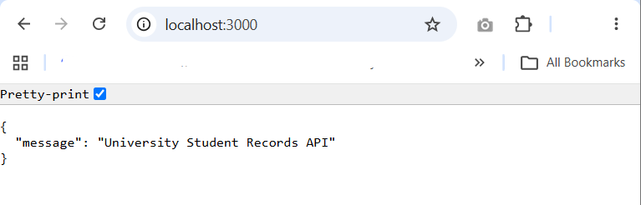

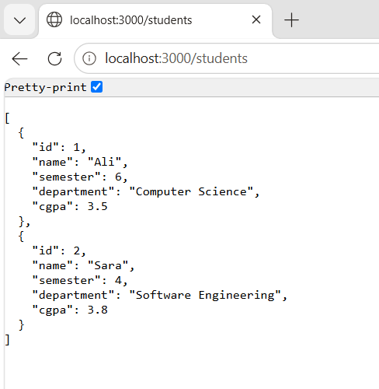
GET /students

GET /students/1
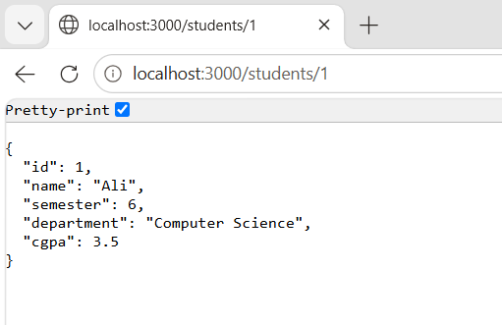

GET /students/4
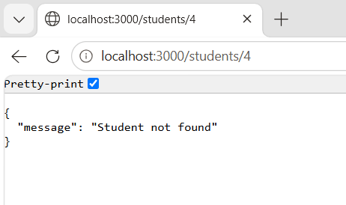

POST /students in Postman
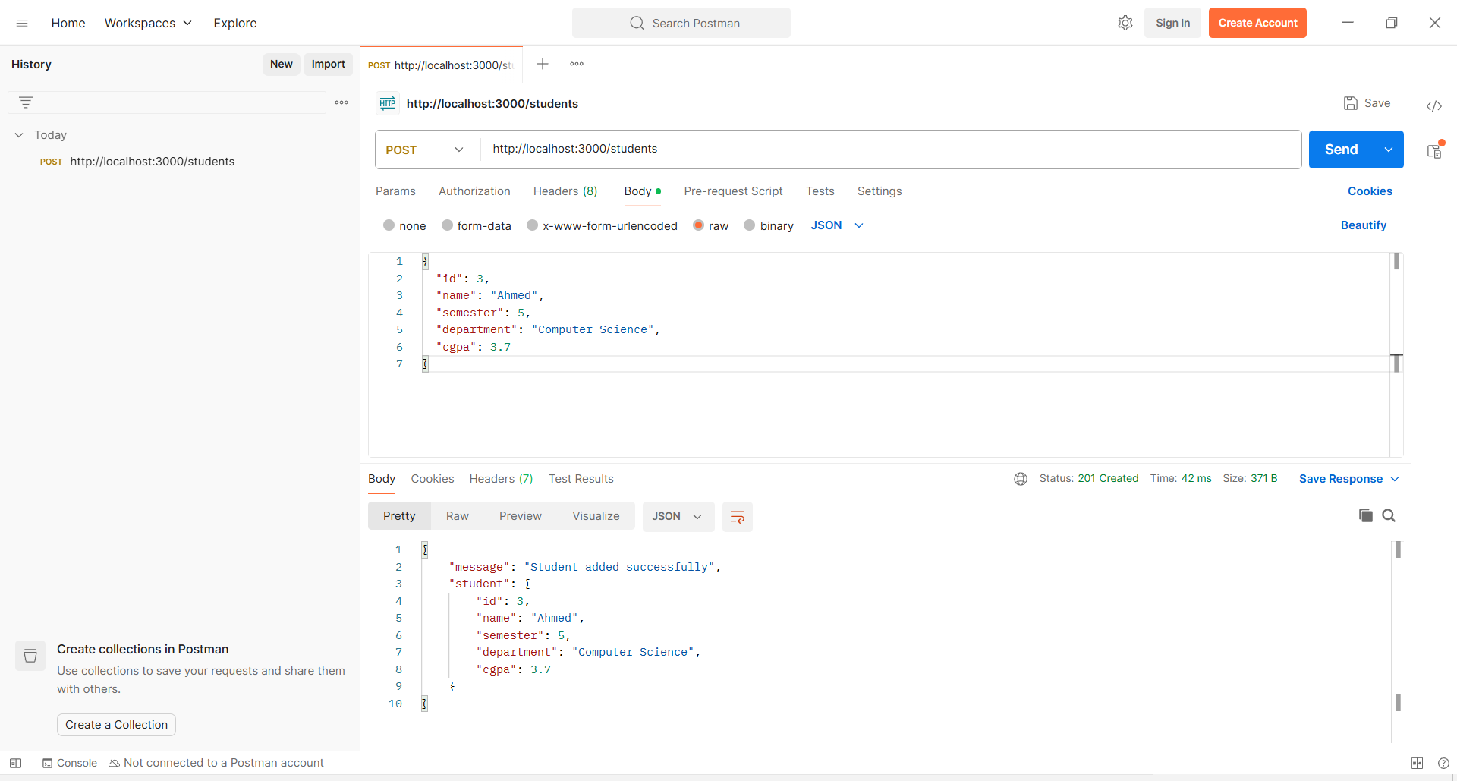

GitHub Repository
https://github.com/nosheenawan467/Task-1-Nosheen-Afzal

Conclusion
The University Student Records API successfully demonstrates the core concepts of REST API Fundamentals. The project implements GET and POST routes, returns structured JSON responses, and follows stateless communication principles. Through this project, practical experience was gained in backend development using Node.js and Express.js.

